4.5 Lovable for Building Lightweight Apps - Teacher's Demonstration Document

Demonstration #1: "FormFlow" – Build-Your-Own Form and Analyze Submissions
Goal: Build a dynamic form-builder app where users can create custom forms, share them, collect responses, and view results. The app will cover form creation, data collection, and analysis, using Lovable.

1. Start a New Project in Lovable
- Navigate to https://lovable.dev
- Click Get started → Continue with Google
- In the start page, explain about:
  - The prompt window
  - The Upload (+ button) option - lets you attach images / figma designs. Can’t upload the code you created in your prototype, but can upload the design as an image).
  - The Public option - for free only Public (anyone can see and reuse it).
  - My Lovable’s Workspace - where your apps will be presented
  - From the Community - to explore varied options of other users
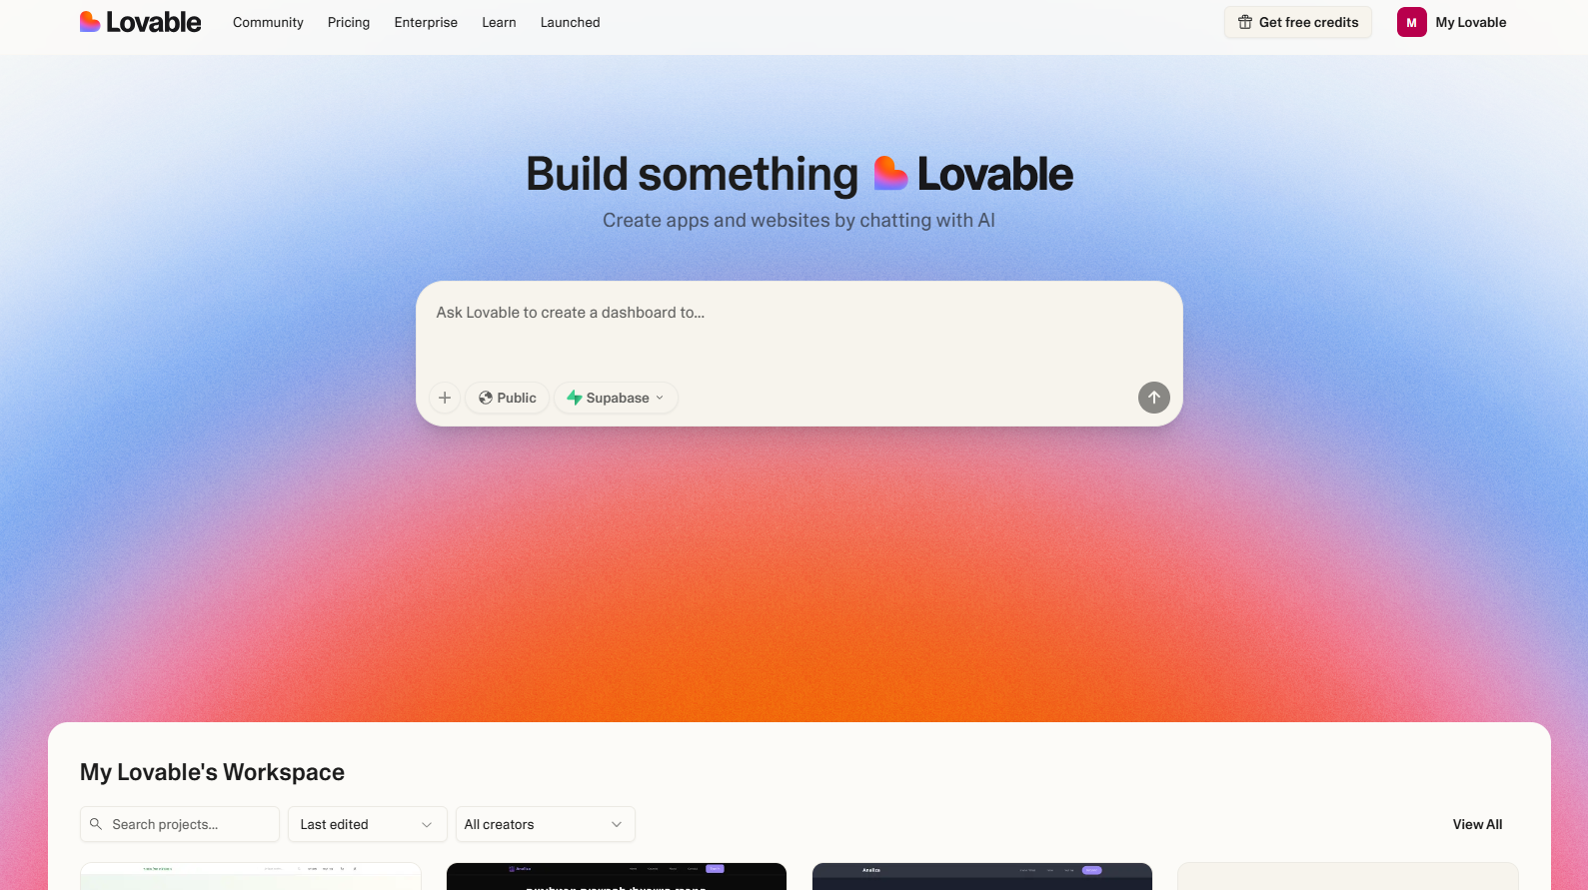

2. Write the initial prompt to ChatGPT and ask them to create for you a requirement doc to use as the prompt
I want to build an app with Lovable. I have no prior knowledge and background in programming. Help me to create a requirement document for my app that I will use as the initial prompt to Lovable.

I want to build an app that lets users create their own forms, share them, and collect responses. The app should include: a form creation page (with form name and creator), a page to fill out the selected form, and a dashboard page that shows all the responses and basic analysis (like charts). Each response should be tied to the relevant form.

Help me refine the idea and to write a requirement doc that I will use as the initial prompt. Write it without emojis or tables, So I will be able to easily copy it to Lovable prompt window.

2. Paste the ChatGPT requirement prompt to Lovable and start building
App Name: Formify (you can change this later)
Objective:
Build a simple app that allows users to create customizable forms, share them via link, and collect and view responses. The app should work smoothly for users with no technical background.
Key Features and Pages:
- Form Creation Page
- Users can create a new form
- Each form has a name and is associated with a creator (user ID or email)
- Users can add multiple questions to the form (text, multiple choice, number, etc.)
- Each question has a label and a type
- Form Submission Page
- Each form gets a unique link
- Anyone with the link can fill out and submit the form (no login required)
- Responses are saved and tied to the specific form
- Dashboard Page (for form creators)
- After login, users see a list of all forms they created
- For each form, they can view all responses
- Basic data analysis:
  - Count of responses
  - Simple charts (e.g., bar chart for multiple-choice, average for numbers)
  - Export to CSV
Users and Roles:
- Only the form creator needs to log in (authentication required)
- Respondents do not need to log in
Database Structure (basic):
- Users: id, email, password
- Forms: id, name, created_by (user_id), created_at
- Questions: id, form_id, question_text, question_type
- Responses: id, form_id, submitted_at
- Answers: id, response_id, question_id, answer_value
Logic Flow:
- Logged-in user creates a form → adds questions → gets a shareable link
- Others open the link → fill the form → submit → answers saved
- Creator logs in → views dashboard → sees responses and analytics
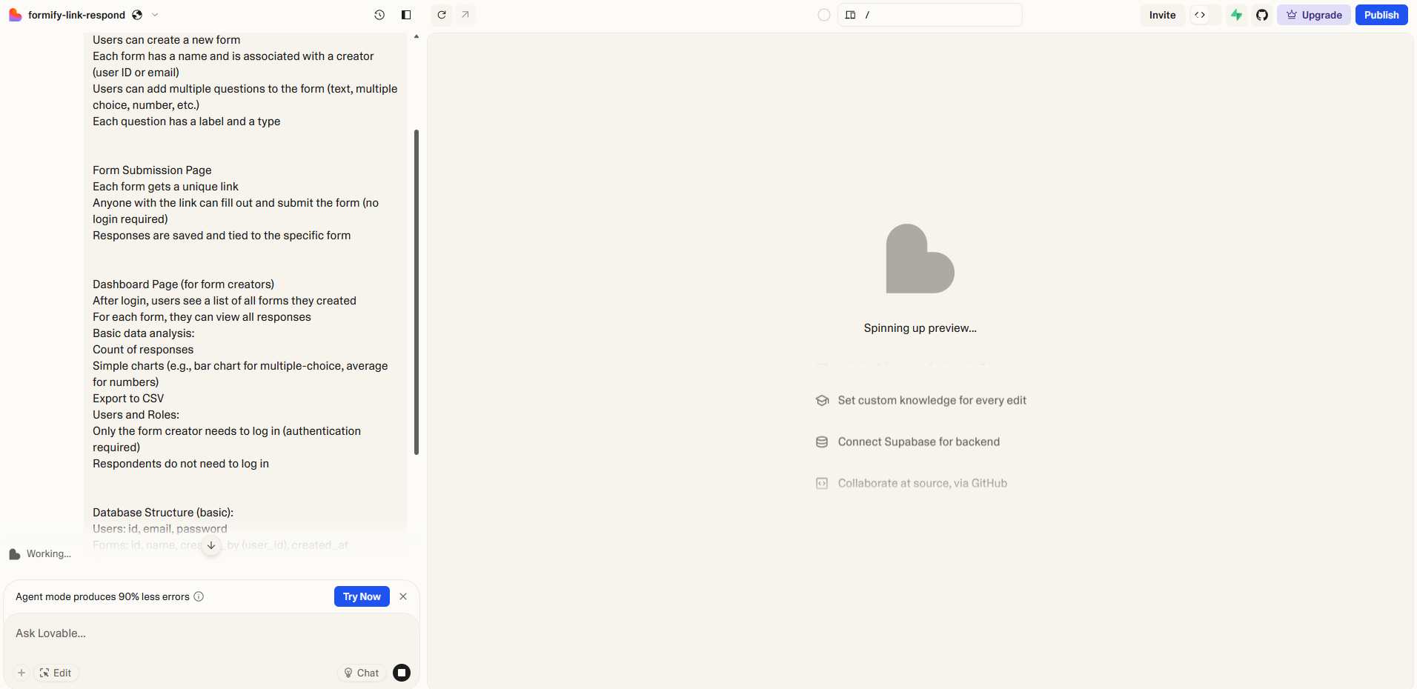

3. Go over the user interface of Lovable
- Show the conversation window and the app preview
- Show the plus (+) button to get to the settings of your generated app and how to connect it to Supabase
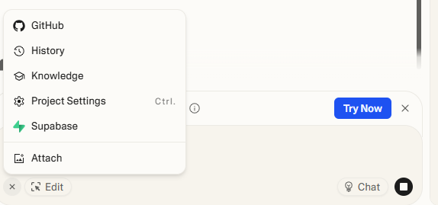
- Explain about the Edit button - allows you to edit and design your app (i.e. texts, colors) without using credits. Example later on.
- Explain about the Chat option - allows you to to make conversations with the LLM for ‘deep thinking and coding’. Don't apply code changes to the app when you are in this mode. Similar to the ‘discuss’ in Base44.

4. Set up the Backend of your created app via Supabase
This is a crucial step that should be taken at the beginning of your building! Much more important than start working on the UI and UX of your app..!
Youtube video explanation on how to Supabase to your Lovable app - https://www.youtube.com/watch?v=95alRldMdaw

Description:
- Press on the plus (+) button → Supabase
- Sign Up to Supabase (entering email and create a password) → confirm via email the connecting of Supabase to Lovable via API → connect back to Supabase → Create new organization
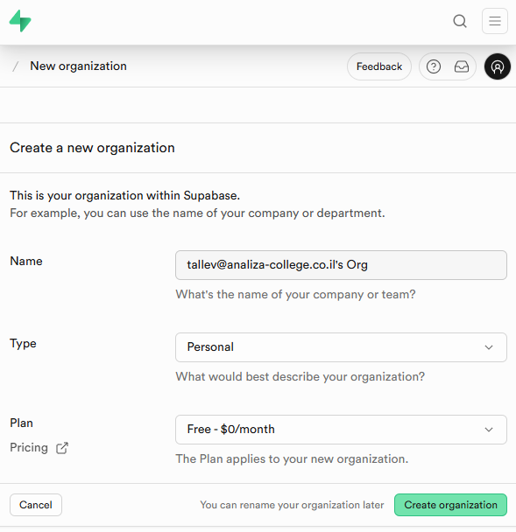
- Organization setup - Generate database password and select a region
- Exit Supabase window and go back to Lovable → plus button → Supabase → connect organization → add your organization and approve the API connection to Lovable → connect your organization.
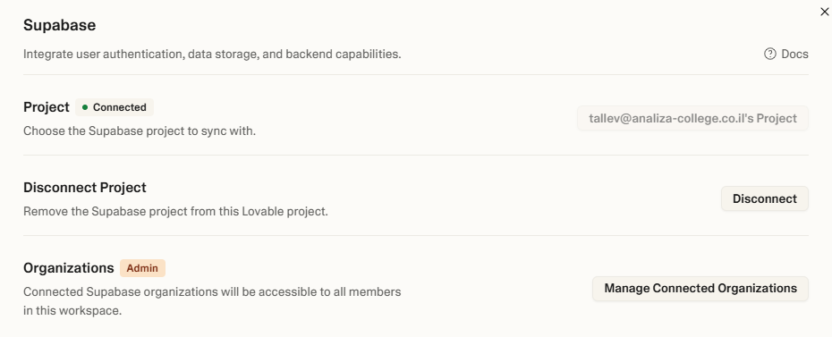
In the Lovable conversation it will look like:
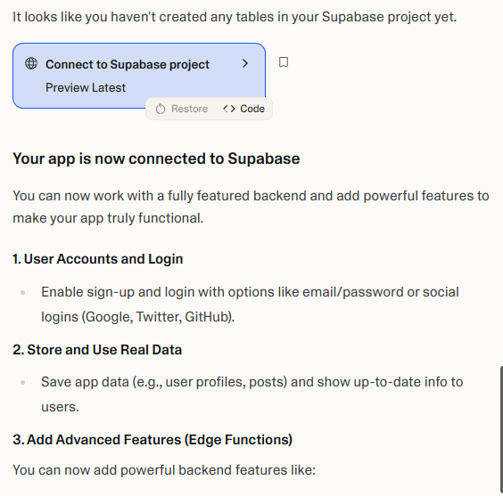

4.1 Setup Authentication via Supabase Dashboard
- Press on “Project dashboard” → The project will open in Supabase
- Explain the students about the dashboard - This is where they will manage their DB, authentication integration, payment integration, AI API integration, etc.
THIS IS THE MAIN DIFFERENT FROM BASE44!!! - much less comfortable (in my opinion) to non technical vibe coders.
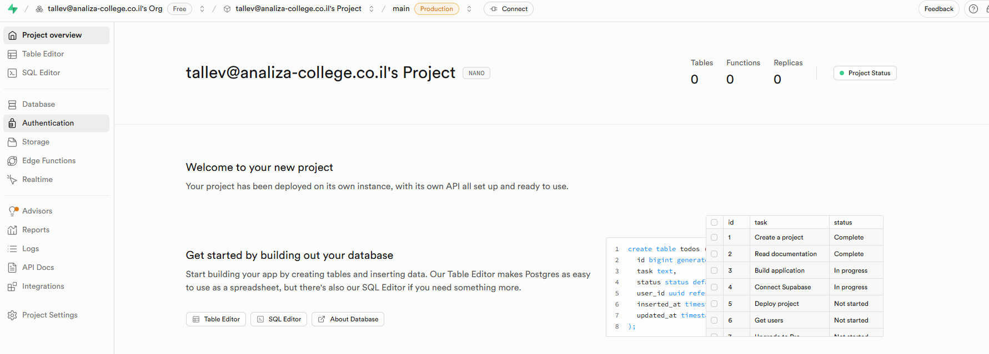
- Press on Authentication → Sign in / Providers → Scroll down to Google → follow instructions to add the Google’s authentication (need to have an account for Google Cloud - console.cloud.google.com). In this video from min 26~.

4.2 Setup DB tables via Supabase Dashboard
After connecting to Supabase, you need to ask Lovable to create the DB!
connect the website to the database in supabase so the forms the user created will be saved. Also, the user's answers to each created form will be saved.

Then it will write the SQL tables for the DB and will ask us to approve: Press on Apply Changes
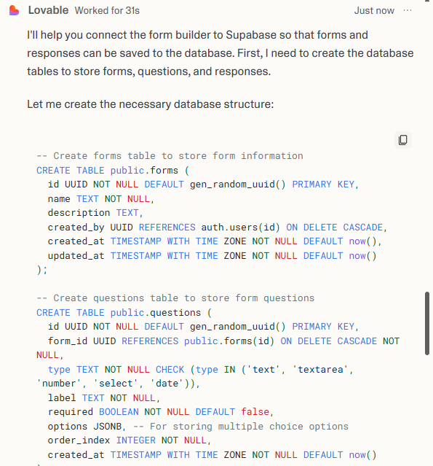
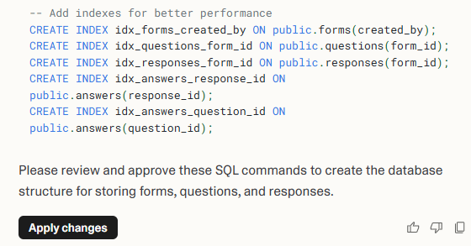
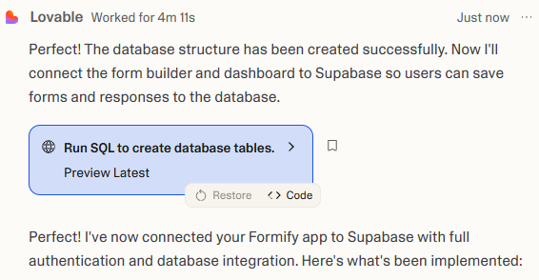
Let’s test!
See the DB scheme in Supabase -
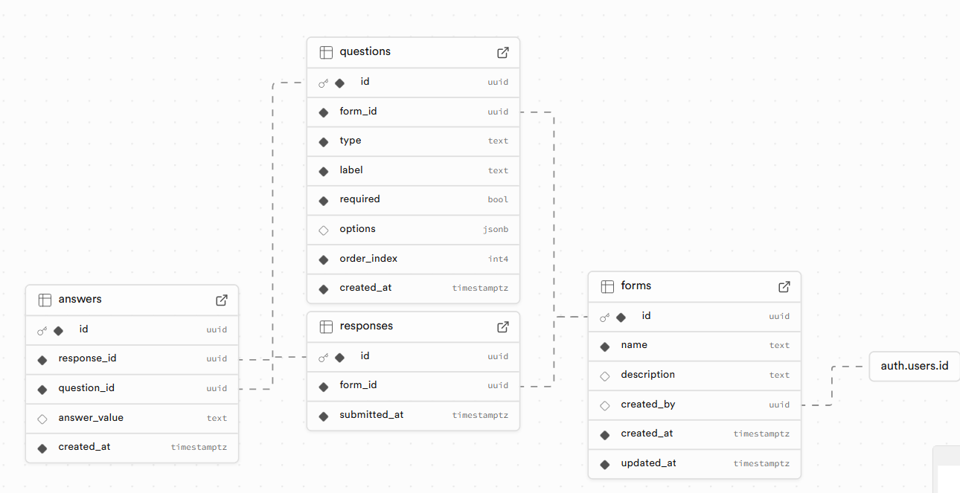
See the tables that have been created -
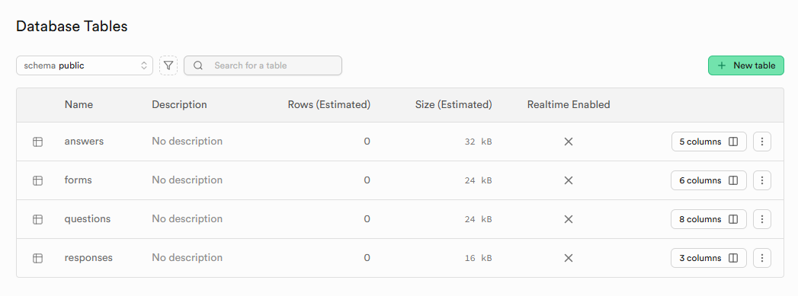
Create a form and see if it saves on the front side of the app.
Then, go to Supabase dashboard and see if the data saved to the DB:
- In the Supabase dashboard, press on Database → Tables → You can see the tables and the form you created, and user entry. In this video from min 33~.

5. Go over the output via the Preview option
Play with the app and explore whether it does what you want it to do.
For example, it has buttons which do nothing. It created an authentication via local sign up and login to the app (backstage - Supabase authentication), it generated mock data information presented in the main page of the app (stats, user reviews etc.).
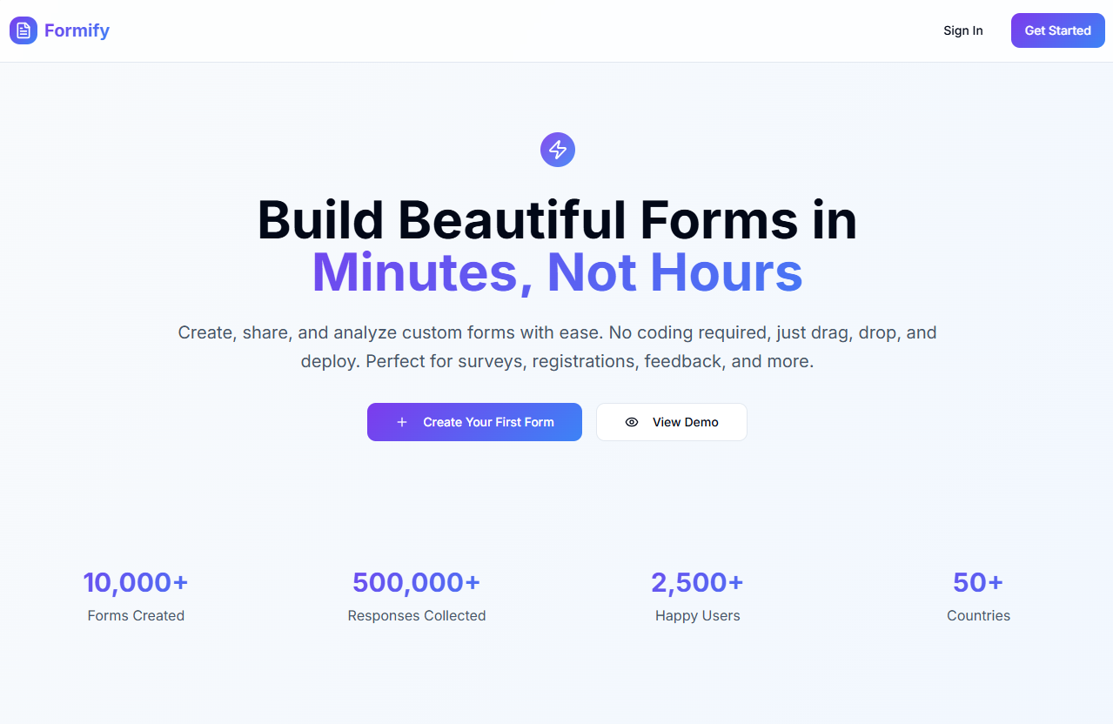

6. Edit option
Press on the Edit button - allows you to make UI edits without spending any credits.

7. Publish the app
Press on the Publish button and copy the URL.

8. Explore improving your initial output!
Write a prompt to improve the app based on the changes you want to make. Write the prompt and see what happens!
Remember - You have limited prompts (in the free of course but also in the paid plans it isn’t endless), so you should be calculated..!

